ORGANIZATION STRUCTURES
There are six basic elements of an organizational structure:
- Specialisation
- Departmentalisation
- Chain of Command
- Span of control
- Centralisation and Decentralisation
- Formalisation
Work specialization gives employees specific duties and roles they are expected to perform within the company, factoring in their qualifications and skills(Recall the KASH -Job Fit). Having descriptions of duties for staff members helps the organisation to fully meet the workforce needs and to ensure there are no unnecessary duplications within roles.
Departmentalization(division of tasks) refers to how the organisation breaks down the functions and teams needed to run the company and carry out the essential tasks. Departments are usually made up of staff members who perform similar tasks in the same work area, but could also be grouped by project, location, or however the organisation sees fit to ensure increased productivity.
The main purpose of an organisational chart is to illustrate chain of command, and ensures that each employee has a clear directive of who they should be reporting to within the company(Hierarchy of authority). The manager responsible for a particular employee will assign them tasks, provide deadlines and motivation, and communicate important messages. If their staff member has an issue, the manager can take this higher up the chain of command for more support if necessary and to provide a resolution(the movement of information that I discussed in class). A clear chain of command ensures messages are being communicated effectively between the relevant staff members.
The span of control is how many employees each manager is given to oversee, and limits to their capacity is set by the organisation. It ensures the efficiency of a company isn’t compromised, as a manager will become less effective at their job if they have too many staff members to supervise and the amount of time they spend focussing on each person will significantly reduce. Managers who are positioned higher up in the chain of command will typically oversee less staff members, as they will be directly responsible for middle managers and supervisors.
Centralization within a business means that middle management does not have a significant input to company decisions, and these are left to top level management only. This is typical of a larger organisation. Decentralization allows all level of management to share their input on the goals and visions of the wider company, which will then help to improve their individual teams.
Organizational structures implement a degree of formalization, and determines the procedures and rules of a company, as determined by management. A smaller organisation might have less formal standards because staff undertake multiples roles and duties, but a larger organization would need to set more defined elements to enable clarity for staff.
The type of organization structure, whether formal or informal, is based on the needs and usually the size of the company. A formal organisation has clearly defined roles and responsibilities for staff, and accountability is fixed within the structure. An informal structure has less set guidelines and restrictions, and is reliant upon the interactions that staff members have with each other. A formal structure has been deliberately created by top line management, but an informal structure would be spontaneous created by staff. This could lead to chaos and confusion if the team grows in numbers, as there may not be a clearly defined hierarchy or procedures to follow to ensure the company keeps working effectively. An informal structure does however allow for flexibility within the organisation, as there aren’t rules in place which could slow down operations.
Some of those structures are very strict and hierarchal, like the bureaucratic model, and some of the structures, like boundaryless, are pretty loose and free-wheeling. They all have their advantages and disadvantages.
When managers combine the basic components and elements of an organizational structure together, the result has certain characteristics that are best understood by looking at it through the lens of organic and mechanistic organizations.

Organic Organizations
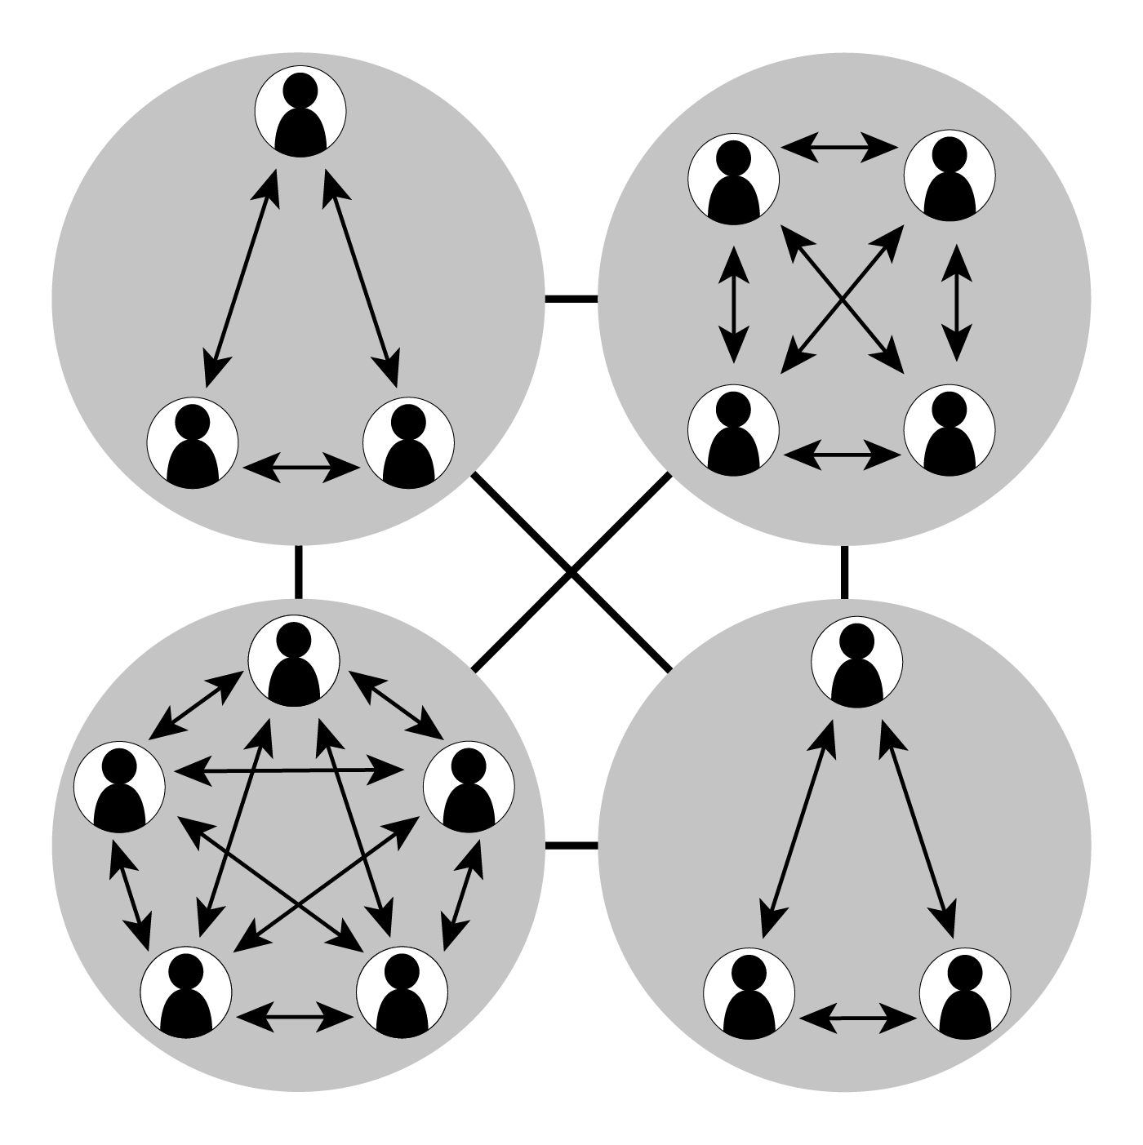

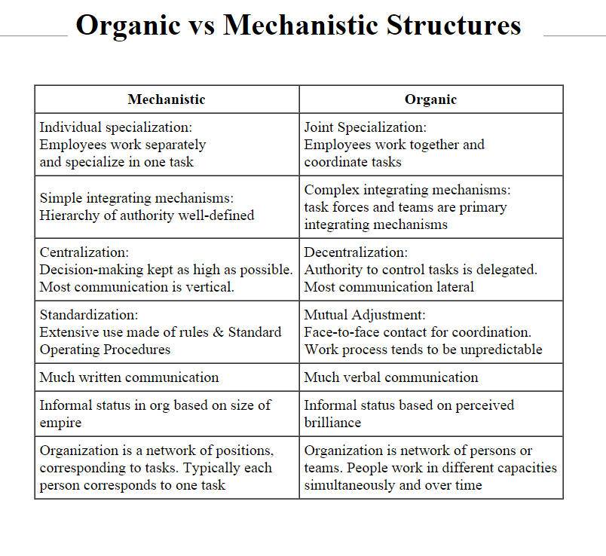

Organic organizations have a low degree of formality, specialization and standardization. Their decision making is decentralized and their activities are well-integrated. The organic model is usually flat, and it usually uses cross-hierarchical and cross-functional teams and possesses a comprehensive information network that features lateral and upward communication in addition to downward communication.
Organic organizations look a lot like boundaryless organizations. They allow for employees to cultivate more ideas and be more creative because the business is not as rigidly structured. Organic structures are used in dynamic, unstable environments where the business needs to quickly adapt to change, as the structure gives the organization the flexibility to deal with fast-paced environmental change and many different elements.
A good example of an organization that uses an organic structure might be a consulting firm. A consulting firm responds to customer issues as they come up, and those issues change with the business environment. Consulting firms want to respond to change quickly, so by choosing an organic structure they’re able to be nimble and address their customers’ needs.

Mechanistic Organizations
Mechanistic organizations have centralized decision making and formal, standardized control systems. Essentially, they are bureaucracies.
Mechanistic organizations work well in stable, simple environments. Managers integrate the activities of clearly defined departments through formal channels and in formal meetings. Often, they feature many hierarchical layers and a focus on reporting relationships.
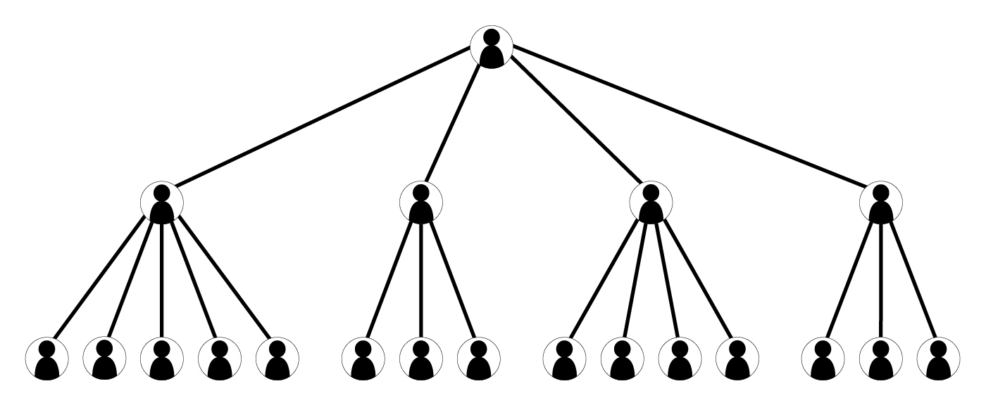

GENERAL MOTORS
General Motors is a good example of an organization using the mechanistic model. Why do they use that? For one, they’re very large, and when that many people and functions are involved, order is needed. But they’re also in a stable, if not somewhat simple, environment. The car market fluctuates with the economy, yes, but the company builds cars and trucks. Across all their divisions, that function is basically the same.

DMV
Another example of a mechanistic model is the Department of Motor Vehicles. When you get your new driver’s license, you go from one department to another, taking a written test, taking an eye exam, taking an actual driving test, filling out the paperwork, and then finally, getting your driver’s license. The structure for this is very mechanistic—every person looking to get a driver’s license has to be treated exactly the same. It’s simple and stable.
Here’s a table comparing the basic characteristics of both models:
Organic | Mechanistic
General tasks | Specialized tasks
Loosely defined departments and hierarchy | Well-defined departments with clear hierarchy
Decentralized decision making by many individuals | Centralized decision making by a few people
Integration achieved by managers and employees interacting and exchanging information as needed | Integration achieved by formal manager meetings
Flexibility and capability of rapid change | Clear and efficient reporting relationships
Most companies find themselves falling somewhere in between the two extremes of organic and mechanistic. Each organization designs its structure to enable its mission, goals, and strategy. If the structure fits with other contextual elements, it has a better chance of being effective in supporting the organization.

